**Intake Sheet, page 1, Shaded Area**

|  |  |  |  |  |
| --- | --- | --- | --- | --- |
| 1: No | 2: No | 3: Yes | 4: Yes | 5: Yes |

**Filing Status - Married Filing Jointly**

**AGI – 66,403**

**Federal Refund - $4,014**

**State Refund -**

**Basic Information**

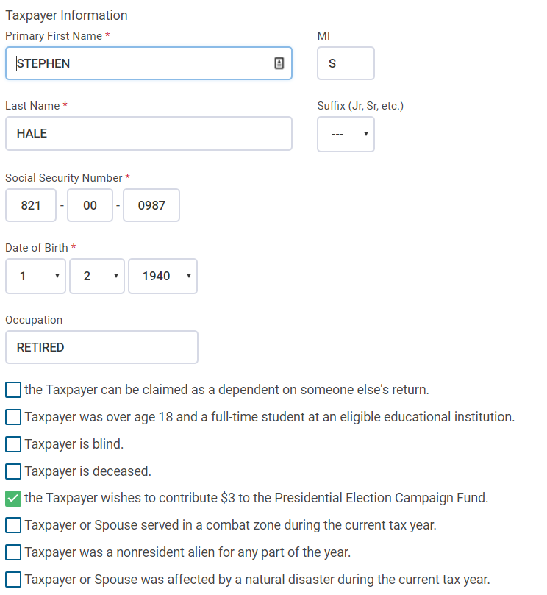

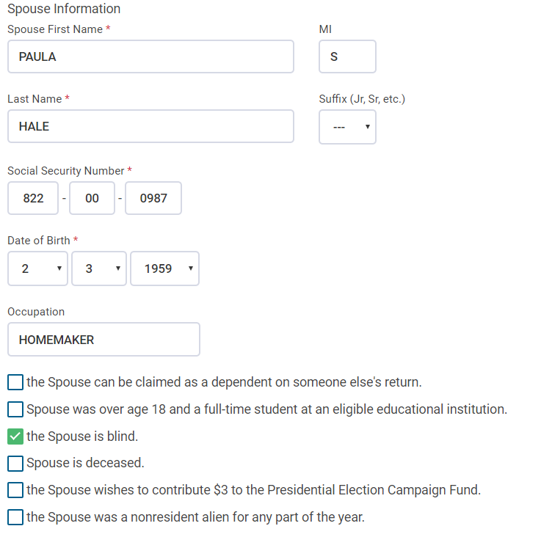

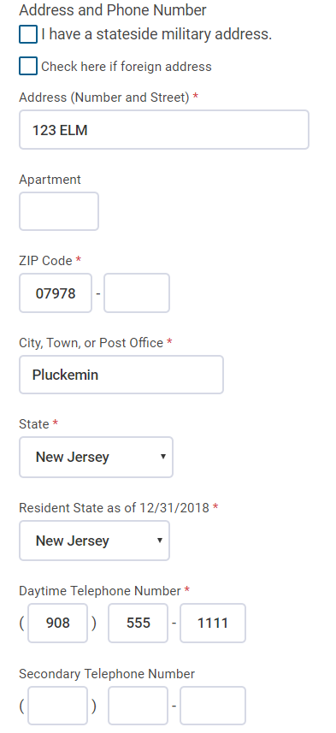

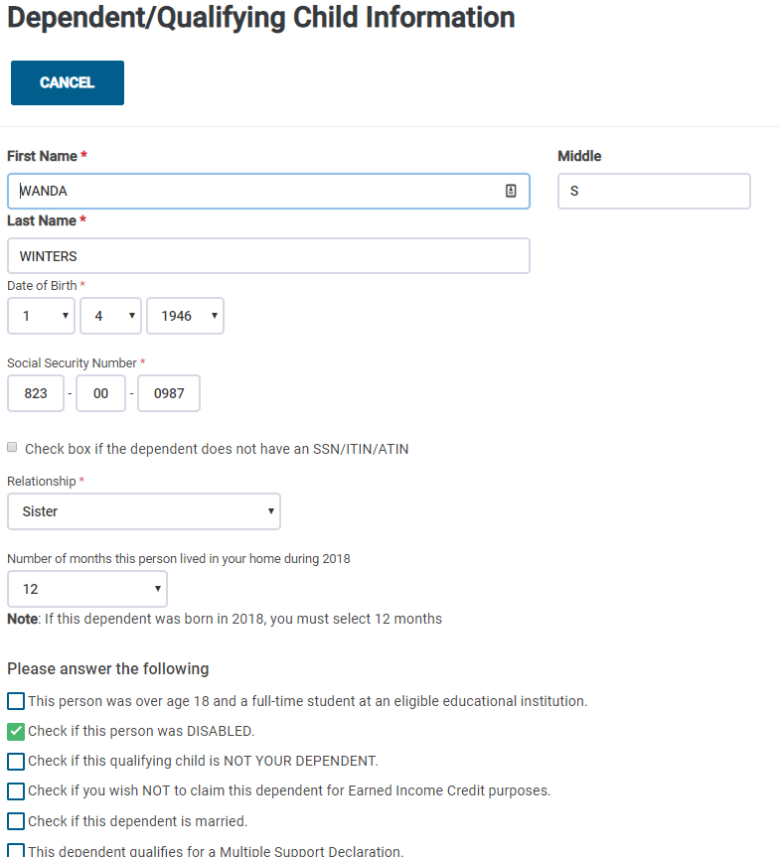

**Interest**

**ACME Brokerage**

Check for EIN and address of 123 Elm. Pluckemin, NJ 07978

Taxpayer selected

Box 1 =125

Box 3 = 506

Box 4 = 50

Box 8 = 338

Box 9 = 4

Savings Bond Interest subtracted from State = 506

State Selected = New Jersey

Edit Interest Items

State = New Jersey

Owner = Taxpayer

Amount = 189

**Dividends**

**ACME Brokerage**

Check for EIN and address of 123 Elm. Pluckemin, NJ 07978

Taxpayer selected

Box 1a = 232

Box 1b = 125

Box 2a = 69

Box 3 = 32

Box 4 = 80

Box 7 = 44

Box 11 = 400

Box 12 = 22

Edit Dividend Items

State = New Jersey

Owner = Taxpayer

Amount = 154

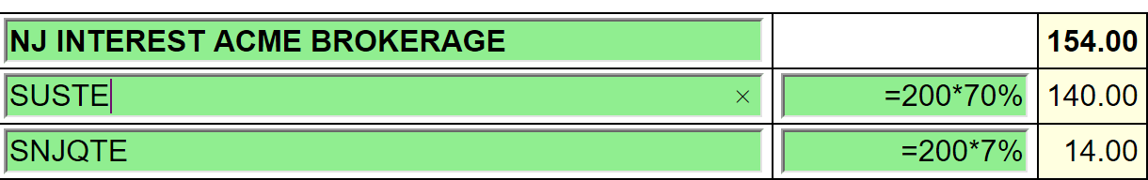

For SUSTE (Not a NJ qualified fund), only the District of Columbia, Puerto Rico and US Possessions

are exempt. 30% is exempt. 70% is taxable.

For SNJQTE (A qualified NJ fund), all the above plus the 70% New Jersey is tax exempt. 93% is

exempt. 7% is taxable.

**1099-R**

Payer EIN= 91-3xxxxxx

**ACME Pensions**

123 MAIN

PLUCKEMIN, NJ 07978

Stephen Hale checked

Box 1 = 23,793

Box 2a = 23,793

Box 4 = 2,379

Box 7 = 7

Payer EIN = 94-3xxxxxx

**OFFICE OF PERSONNEL MANAGEMENT**

PO BOX 45

BOYERS, PENNSYLVANIA

Stephen Hale Checked

Box 1 = 18,625

Box 2a = 18,006

Box 4 = 1,862

Box 5 = 2,300 – This amount should be put in Sch A Medical – Insurance

Box 7 = 7

Box 9b = 15,984

State Tax W/H = 700

Box 13a = New Jersey

Box 13b = 943xxxxxx

Box 14 = 18,006

Difference between Box 1 and Box 2a to be entered on the NJ Checklist = 619

Simplified Rule Worksheet - See Bogart Annuity Calculator Print Out – Best practice is to

use the Bogart Calculator to determine the correct numbers and insert into the TSO simplified

worksheet.

* + - Plan Cost 15,984
    - Start Date 2/1/2011
    - Check Joint Annuity Box
    - Age of recipient at start date – 122
    - Number of months paid in 2018 – 12
    - Amounts previously recovered – 4281

Taxable amount Box 2a – 18,006

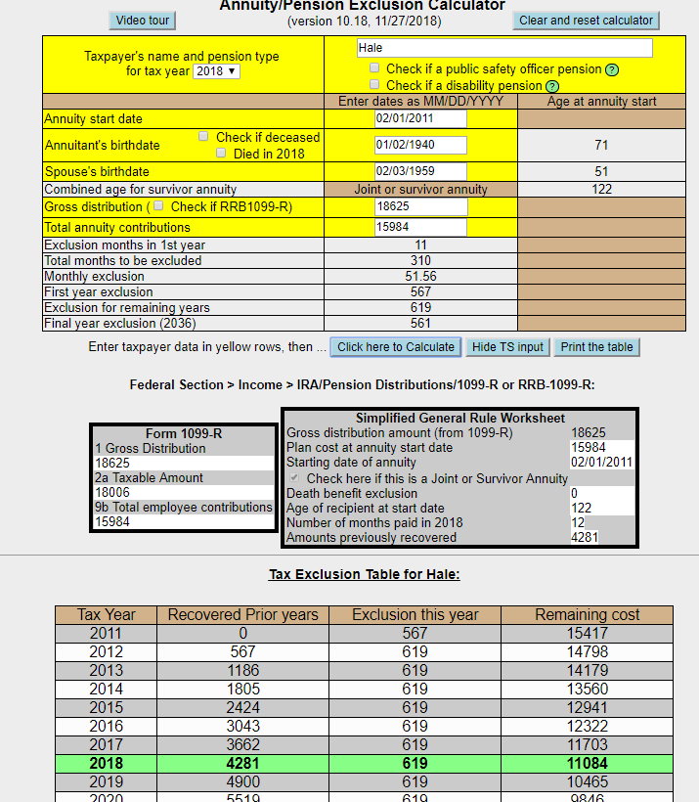

EIN = 92-3xxxxxx

**ACME IRAS**

123 MAIN

PLUCKEMIN, NJ 07978

Paula Hale checked

Box 1 = 1,000

Box 2 = 1,000

Box 4 = 100

Box 7 = 7

IRA Box Checked

Question 1 – If she took a distribution in June she would not have been 591/2 and would have be

subject to a 10% penalty.

Question 2 – The TP was in a 10% tax bracket. The $100 withholding was the exact amount of the tax

increase.

**SSA-1099**

Benefit = 15972

Federal Tax Withheld = 550

Medicare Premiums = 2,195

**Capital Gains**

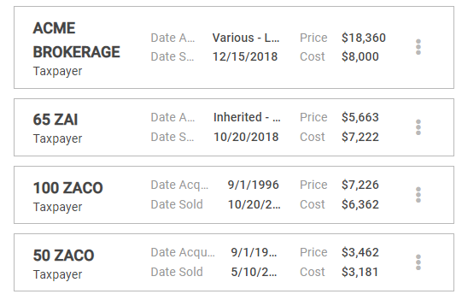

Cost Basis Not Reported

Cost Basis Not Reported

Cost Basis Not Reported

Cost Basis Reported

* ZAI – Check that Wash sale was entered @$97
  + Adjustment description = “Nondeductible loss from wash sale”
* ACME Brokerage – Consolidated entry –
  + Description – ACME Brokerage
  + Date Acquired – Alternate Option – Various Long Term
  + Date Sold – Use latest date sold
  + Adjustment description = “Reporting Multiple Transactions on a Single Row”
* Other Capital Gains Data – Long Term Carryover = 12,454

**K-1**

Entity Information

* Be sure Form 1065 was used and Entity Information should be checked as shown below:
* Steven Hale checked
* Acme Partners
* EIN – Includes a number
* 123 Main, Pluckemin, NJ 07978

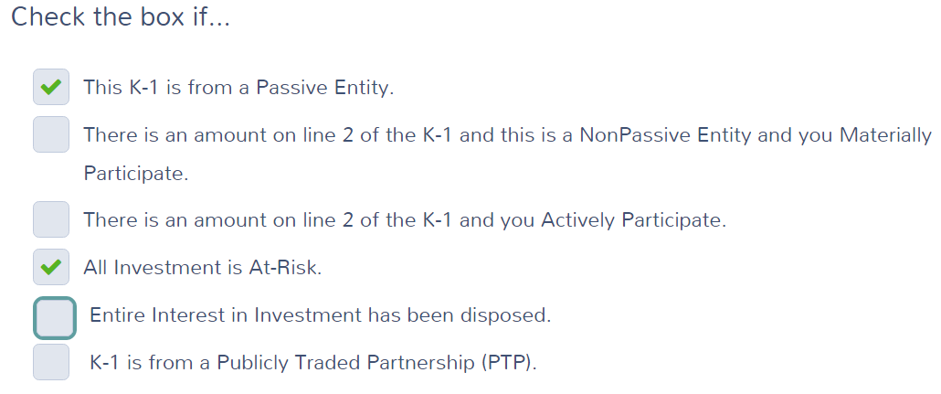

Income

Box 5 = 343

Box 6a = 474

Box 6b = 101

Box 8 = 72

Box 9a = 218

Box 18A = 31

**W2G Gambling Winnings**

* For Paula
* EIN – 22-2472727
* New Jersey Lottery
* PO Box 41, Trenton, NJ 08625
* Winnings = 10,000
* Gambling Losses = 12,000 (TaxSlayer will only carry over 10,000 to Sch A)
* Federal Tax Withheld = 2,000
* Type of wager = Lottery
* Date Won = 7/15/2018

Log total gambling winnings, losses and NJ lottery winnings in the NJ checklist

The Federal AGI went up more than the lottery winnings because more of the TP Social Security was taxed.

**Other Income – Homestead Benefit Recovery**

Check to be sure the Homestead Benefit Recovery of 400 was included in Other Income

**Estimated Tax Payments**

State Estimated Payments

4/15 = 60

6/15 = 60

9/15 = 60

12/31 = 70

Note: The $50 NJ estimated payment made on 1/3/2018 for TY 2017 is not entered here. See Itemized deductions – Taxes You Paid.

**Itemized Deductions**

* **Taxes You Paid**

1. 203 paid for last year’s taxes plus

2. 42 paid for taxes owed from three years ago

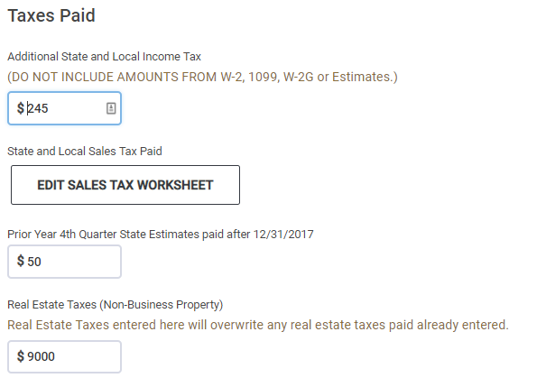

Estimated tax payments to NJ made on 1-3-16 for TY2017.

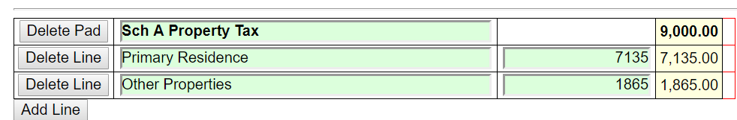

Sales Tax Worksheet

* + Enter NJ and 365 days and Zip 07978

Itemized deductions only went up by 8,755 because the total of property tax and state income tax was capped at 10,000.

* **Medical** 
  + Medical Insurance

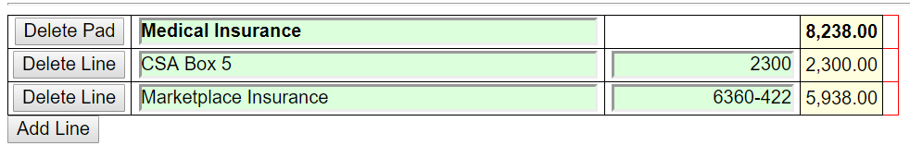

Note: The 422 is the APTC the taxpayer received on Schedule 5 Line 70

* + Doctors = 300
  + Long term care
    - Be sure Paula is selected from the drop-down menu for long term care insurance
      * Amount = 1530 – TaxSlayer will not allow 1800 input due to age of payer
* **Mortgage Interest**
  + Mortgage Interest Reported on Form 1098

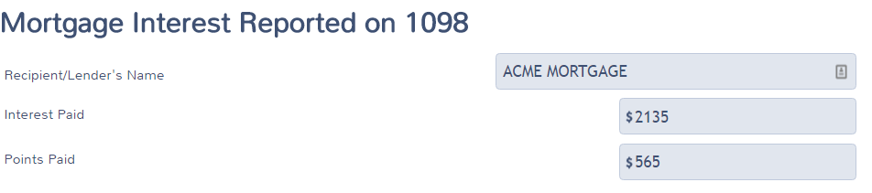

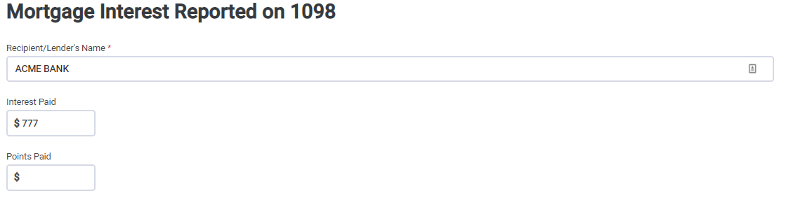

* **Gifts to Charity**
  + Cash = 600
* **Misc. Deductions**
  + Gambling Losses
    - Check to see that Gambling Losses = 10,000 is included in Sch A
* **Health Insurance**

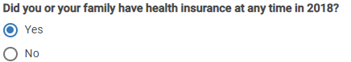

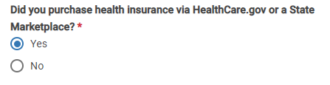

Verify your Household Members – CONTINUE

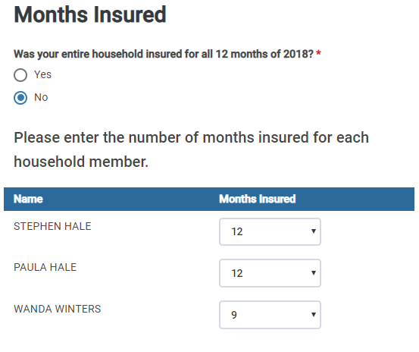

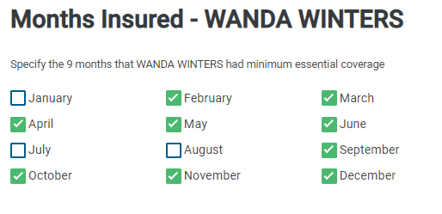

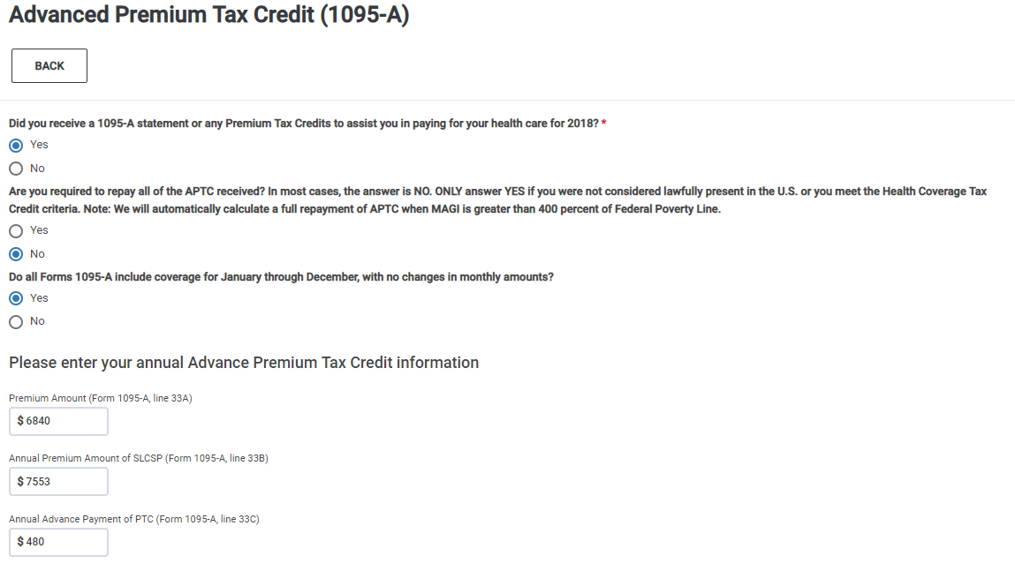

Dependents' Modified AGI (if filing requirement) - None – CONTINUE

Do you qualify for Health Care Exemptions? Continue on the first screen.

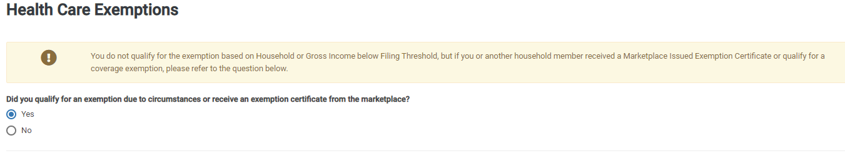

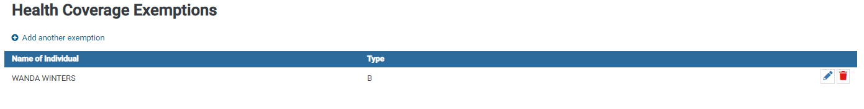

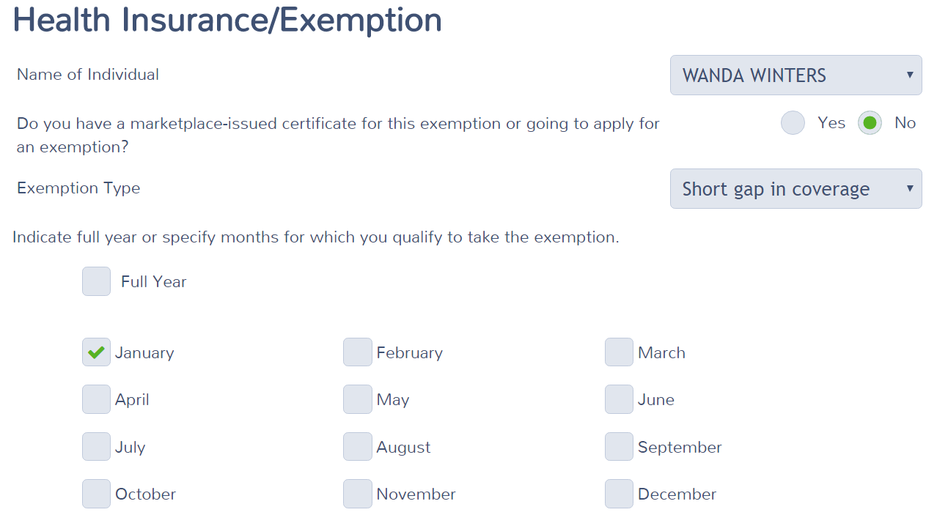

**E-File**

The Efile screens have not been updated in TSO 2018. Check that the Federal File Type has been entered and the bank information for direct deposit has been entered.

**STOP UNTIL NJ IS AVAILABLE IN TAXSLAYER**

**New Jersey Return**

Check that the numbers shown in the NJ Checklist below have been properly entered in to TaxSlayer.





Note : Property Tax Credit. Did you meet Property Tax Eligibility requirements?



Where you a homeowner in 2018?

Yes, to both questions.

Block – 50001

LOT – 00002